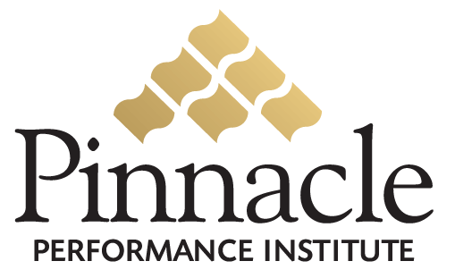

Pinnacle Virtual Coaching System

Plano, Texas, Wednesday, November 10, 2004 –
Pinnacle Performance Institute is proud to announce the Pinnacle Virtual Coaching System for corporate and personal trainers, public speakers, business consultants, business coaches, personal coaches and mentors.
Pinnacle’s Virtual Coaching System provides a private-labeled customizable platform for Coaches to deliver training and communication tools to maximize team and personal performance on all aspects of life.
Pinnacle provides (at no cost to the Coach) a secured, customized back-office enabling Coaches to setup their own Virtual Coaching System. Coaches can train different groups with specific needs from their private courses and from the hundreds of public courses in the Pinnacle catalog.
In addition to all this, members receive personal and professional assessments, a suite of communication programs and unlimited access to the hundreds of training courses available anytime, from anywhere. They can even take a free
3-day test-drive.
A Personal Membership retails for only $49.95 per month. The Professional Membership includes 3 accounts for only $119.95 ($39.95 ea. - a $30 savings). As an option, Pinnacle can bill the member directly.
Coaches can create a residual revenue stream by signing up members in their Virtual Coaching System. Pinnacle provides this System at absolutely no cost to the Coach.
This complete turnkey system generates a profit for the Coach of 25% of the membership fee every month for the life of the account!
Pinnacle Performance Institute, headquartered in Plano, TX, is a premier technology company with a passion for performance. Pinnacle leverages technology in assisting companies to “Close the Gap” between their vision and their execution.
For more information about Pinnacle Performance Institute, visit the company’s Web site at http://www.pinnaclep.com.

